PUMPKIN MUFFINS
Serves 14
40 min
Sweet, moist and easy to make, these warmly spiced pumpkin muffins are good for baking with children. For an easy frosting, beat together 300g cream cheese, 100g butter, 100g icing sugar and a teaspoon of vanilla extract until soft.
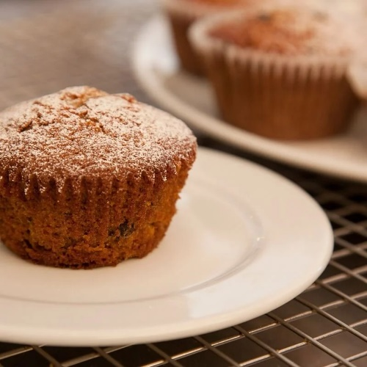
Ingredients

115g butter or margarine
175g brown sugar
115g golden syrup or honey
1 egg, beaten
225g pumpkin or squash, cooked and mashed
200g plain flour, sieved
pinch salt
1 tsp bicarbonate of soda
1½ tsp ground cinnamon
1 tsp nutmeg, grated
50g currants or raisins

Method
Prep time: 10 min
Cooking time: 30 min
Step 1
Preheat oven to 200°C/Gas 6 and place 14 paper cases in a muffin tray.
Step 2
In a large bowl cream the butter until soft. Add the sugar and golden syrup and beat until light and fluffy.
Step 3
Stir in the beaten egg and pumpkin until well mixed. Sift over the flour, salt, bicarbonate of soda, cinnamon and nutmeg. Lightly fold these ingredients into the mixture.
Step 4
Stir in the currants or raisins and spoon the mixture into the prepared muffin cases. The cases should each be about two thirds full of the mixture.
Step 5
Bake in the centre of the oven for 12-15 minutes.

